Sonic Firmware Documentation

RS232 version uses the kenwood cable and has 200 history entries
USB version uses USB-C cable and has 100 history entries,
◀️ Join the SonicFw Telegram https://t.me/SonicFw
📺 Youtube Channel https://www.youtube.com/@robby_69400
💾 DOWNLOAD select RAW file DOWNLOAD_HERE
🙏 Many thanks to Sonic Team : Zylka, Kolyan, Iggy, Toni, Yves and Francois.

This software is a fork of Armel F4HWN firmware with code from NTOIVOLA, EGZUMER and DUAL TACHYON.

Installation

use the same procedure as F4HWN, after that :
- If necessary, you can do a full reset of the radio. press the PTT and Fn2 buttons , turn on the radio. A warning message will be displayed on the screen. hold the buttons for 4 seconds before resetting.

CHIRP Driver

Chirp_Sonic.py in DOWNLOAD_HERE
This driver also allows
- customization of the 50 bands on channels 976 to 1024.
Select start frequency and offset as stop frequency, step and modulation

EXPLANATION OF BUTTON SYMBOLS:

1 – Simple press.
L1 – Long press.
F1– Press after the F button.

MR MAIN SCREEN (CHANNELS) | VFO (FREQUENCY)

L1 – (MR) – Transfer the channel frequency to VFO mode. (VFO) – Change of range.
L2 – (MR and VFO) – VFO change (in MAIN ONLY mode, icon indication).
L3 – Change the MR/VFO modes on the selected channel.
L4 – (MR and VFO) – Bandwidth change.
L5 – (MR) – Change the list number for the channel. (VFO) – Change of step.
L6 – (MR & VFO) – Power Change (L/M/H).
L7 – (MR and VFO) – On/Off flashlight indication when receiving a signal.
L9 – (MR and VFO) – On/Off constant backlight.
L0 – AM/FM/USB Modulation Change
F1 – 1CALL – Quick Call.
F2 – (MR) – Delete Channel. (VFO) – Preserve the frequency.
F7 – Spectrum analyzer in scanlist mode.
F8 – Band Spectrum Analyzer.
F9 – Spectrum analyzer in frequency mode.
F0 – Radio broadcasting (FM radio).
Fn1 and Fn2—Side assignable buttons.
<= and => – Navigation buttons.
MA – Menu.
EXIT – Exit.
#F – Functional "F".

FREQUENCY OR LIST SCANNING IN MR/VFO MODES

In MR (Channel) and VFO (frequency) modes, you can scan by channel or by frequency range with a set step. To scan in frequency mode, press the * button, this will start the scan. In channel mode, the * button changes the scan lists. You can also change the lists by simply entering numbers from the keyboard.

OPERATION IN SPECTRUM MODES

Different types of spectrum are called by the quick buttons F7 , F8, F9 in any of the spectrum modes, you can change them by pressing 6.
1 – Skip the frequency in the scan mode.
2 – Turn on/off the backlight).
3 – Bandwidth in the spectrum. In the options menu, change the value.
4 – List of scanned lists or bands. Already in the selection mode, mark the selected ones with it (highlighted in bold and with a checkmark on the right).
5 – Options menu. Navigation through the menu <= and =>. Change the values of buttons 1 and 3.
6 – Changing the modes of the spectrum analyzer Scanlists/Frequency/Range/Bands.
7 - Save Settings. Save after configuring and selecting the lists and the options will be applied once enabled.
8 – Change the display screen.
9 – Change of AM/FM/USB modulation.
0 – Switch to the history mode.
* and # DYNSQL Level setting - RSSI spike threshold for instant peak capture. For weak and fuzzy signals, increase or disable.
L* and L# DYNSQL OFF This will fill the history, but won’t stop.

Keys in history

1 – Clears all history (use 8 to save).
2 – Saves the frequency to a free channel.
3 – Delete the entry.
4 – Clears all black listed entries (use 8 to save).
5 – Scans history entries.
7 - Clears all non black listed entries (use 8 to save).
8 –Saves the history.
0 –Sort the history.

PARAMETERS OF THE SPECTRUM ANALYZER
LIGHT OR ADAVANCED – LIGHT shows a simplified menu (in red below)
RSSI DELAY – Delay in RSSI measurement before frequency change (in ms) – affects the scanning speed.
SPECTRUMDELAY – Pause time after signal detection (in ms) – if 0, immediately resumes scanning.
MAXLISTENTIME – Maximum time to listen to the signal (in seconds) – after that, the scan continues.
FSTART – Initial frequency of the scan range (in MHz).
FSTOP – End frequency of the scan range (in MHz).
STEP – Frequency scan step (in kHz): 0.01; 0.05; 0.1; 0.5; 1.0; 2.0; 5.0; 6.25; 10.0; 12.5; 20.0; 25.0; 50.0; 100.0.
LISTENBW – Bandwidth: Wide (25 kHz) / Narrow (12.5 kHz)/ AIR (8.33kHz).
MODULATION – Modulation type: FM/AM/USB.
POWERSAVE – Power saving mode: Off /200ms /500ms /1s /2s /5s.
KEY UNLOCKED – THE TIME BEFORE THE KEYPAD IS LOCKED.
NOIS LVL OFF – Noise level for disabling reception (above this – the signal is counted).
GLITCHMAX – The threshold of the GLITCH indicator BK4829. Increase – more buggy signals will be considered valid.
POPUPS – Popup display time (in ms) – 0 = disabled.
RECORD TRIG – An additional threshold for recording in history. The higher the threshold, the stronger the signal will be recorded.
SOUND BOOST – Amplify sound. Increase bass frequencies.
PTT – What to do when pressing PTT: LAST VFO /NINJA /LAST RECEIVED/AUTO ROGER .
- NINJA chooses a random frequency in the current scanlist.
- AUTO ROGER :Choose your Roger in vfo menu, select a frequency or a channel in vfo, in spectrum select ptt auto Roger in the menu, it will send a Roger beep every duration you select.
MONITOR SL – Includes the "MON" priority list in all scan lists.
RESET DEFAULT – Reset all spectrum parameters to factory settings.
SCAN NORMAL / SCAN INTERLACED: when interlaced, the step is minimal 25k and the spectrum is swept with different start frequencies to cover all the frequencies.
For example 125.100, 125.125,… then 125.10833,125.133333…then 125.11666,125.3666…
This can improve detection.

DETAILED MONITORING IN SPECTRUM MODE VIA THE "MENU" BUTTON

Move through the low-level register menu with buttons 2 and 8. Change values with the <= and => buttons
LNAS – Low Noise Amplifier (LNA) – signal amplification stages in front of the mixer.
LNA – Gain of the first LNA stage – higher = stronger signal but more interference.
PGA – Programmable Gain Amplifier (after LNA). – Balance between sensitivity and distortion.
MIX – Mixer Gain (Frequency Mixing) – Higher = Better Dynamic Range but More Noise.
XTAL F MODE SELECT – Quartz filter (XTAL) operating mode. Filtering (reduces noise, but can distort).
OFF AF RX DE-EMP – Disable demphasis (pre-distortion correction) during reception.
GAIN AFTER FM DEMOD – Adjusts the reception volume.
RF TX DEVIATION – Transmission frequency deviation (Fm deviation) – affects the transmission bandwidth (higher = louder).
COMPRESS AF TX RATIO – Compression ratio of audio during transmission – compresses the dynamic range.
COMPRESS AF TX 0 DB – Compression level 0 db during transmission – the compression start point.
COMPRESS AF TX NOISE – Noise reduction in quiet areas.
MIC AGC DISABLE – Disable automatic microphone gain control (AGC).
AFC RANGE SELECT – Operating range of AFC (Automatic Frequency Tuning).
AFC DISABLE – Disable AFC.
AFC SPEED – AFC Speed.

OPERATION IN BROADCAST RADIO MODE "FM"

The firmware has a simplified FM radio. Use the <= and => buttons to search for the nearest available broadcasting frequency in automatic mode. The * button will change the Auto mode to manual search.
Press key 1 to 6 to select the corresponding memory.
Long press key 1 to 6 to save a frequency to that memory.

MAIN MENU

THERE IS NO HIDDEN MENU IN THE FIRMWARE

 | Step | The frequency step (in kHz), UP and Down buttons change the frequency to this value, and you can only set the frequency to half of this value. For CB - 5/10 kHz; SatCom, Avia - 5/25 kHz; The rest is 6.25/12.5 kHz.
 | SQL | The level of noise cancellation (Squelch) is from 0 (always open) to 9 (very strict). Set for both bands (A and B)
 | Mode | Demodulation mode, default - FM, AM and USB can only be used for listening
 | RxMode | Sets how the high and low frequencies are used on the screen (MAIN ONLY - Always transmits and listens on the main frequency (MO), DUAL RX RESPOND - Listens to both frequencies, if the signal is received on the secondary frequency, it is fixed on it for a couple of seconds so that you can answer the call (DWR), CROSS BAND - always transmits on the primary frequency and listens on the secondary frequency (XB), MAIN TX DUAL RX - always transmits to the main, listens to both (DW).
 | RxDCS | Setting Digital Coded Squelch, if enabled, the squelch will only open after receiving that subtone, applicable for FM modulation only.
 | RxCTCS | Setting an analog subtone to reception (Continuous Tone Coded Squelch), if the function is enabled, the noise canceler will open only after receiving this subtone, applicable only for FM modulation.
 | TxDCS | Setting the digital encoded digital subtone to transmit, if the function is enabled, the transceiver will transmit this tone, applicable only for FM modulation.
 | TxCTCS | Setting the analog subtone to transmit, if the function is enabled, the transceiver will transmit this tone, applicable for FM modulation only.
 | TxOffs | Transmitter frequency offset value in MHz, transmit/receive at different frequencies.
 | TxODir | Direction (+/-) of transmitter frequency offset when transmitting/receiving at different frequencies
 | W/N | The bandwidth used by the transceiver (WIDE (25 kHz), NARROW (12.5 kHz).
 | SetNFM | Sets Narrow FM to Narrow or Narrower
 | Compnd | Compander - Soft audio filter for clearer sound. Amplifies the received desired signal even when the signal is weak at the transmitting microphone, improving the signal-to-noise ratio. To work, it must be turned on on both walkie-talkies.
 | Roger | On/off "roger beep" (end-of-pass tone).
 | 1 Call | One key call channel, allows you to quickly switch to a channel by pressing the 9-Call button
 | STE | Noise suppressor, eliminates noise at the end of the transmission. When PTT is released, a short 55Hz tone is emitted, signaling to other transceivers to mute
 | RP STE | Noise Cancelling Tail Eliminator Repeater
 | ChName | Name of the memory channel.
 | ChDisp | Choose how the saved channel will be displayed on the walkie-talkie display
 | F1Shrt | Function assignment by short pressing the F1 side key.
 | F1Long | Function assignment when the F1 side key is pressed for a long time.
 | F2Shrt | Function assignment by short pressing the F2 side key.
 | F2Long | Assign a function when you press the F2 side key for a long time.
 | M Long | Assign a function when you long press the M key
 | KeyLck | Automatically lock the keypad after a set time
 | TxOut | Transmit Timeout - The amount of time that PTT can be held during transmission (in seconds). Protection against accidental clamping of PTT.
 | BatSav | Battery Save: OFF / 1:1 / 1:2 / 1:4 / 1:8.
 | Mic | Microphone sensitivity (microphone amplifier).
 | POnMsg | Enable/disable the display of a message when turned on (Power On Message).
 | BLTime | Screen backlight time when buttons are pressed.
 | BLMin | Minimum backlight brightness (in percentage).
 | BLMax | Maximum backlight brightness (in percentage).
 | BLTxRx | Transmit/Receive Backlight: OFF/TX/RX/TX+RX.
 | SetInv | Enable walkie-talkie screen color inversion
 | BtnInv | Reverse the direction of the UP and DOWN buttons
 | SetLck | Setting the keypad lock type with or without PTT.
 | BatTxt | Battery Display Type, %, V or disabled.
 | MicBar | Enabling/disabling the microphone bar
 | SetTmr | Set the display of RX/TX timers on the screen
 | F Lock | Setting up Frequency Lock. What frequencies are allowed or prohibited to work on.
 | BatCal | Battery Calibration.
 | BatTyp | Choice of battery type (Li-ion, NiMH, etc.) and capacity.
 | Reset | Channel Preservation Reset (NOCH) or Full Factory Reset including Saved Channels (ALL)

Chirp Configuration
- Memory channels 975 to 1024 store custom band settings. For each, define:
  - Band Name.
  - Start and End frequency (via offset).
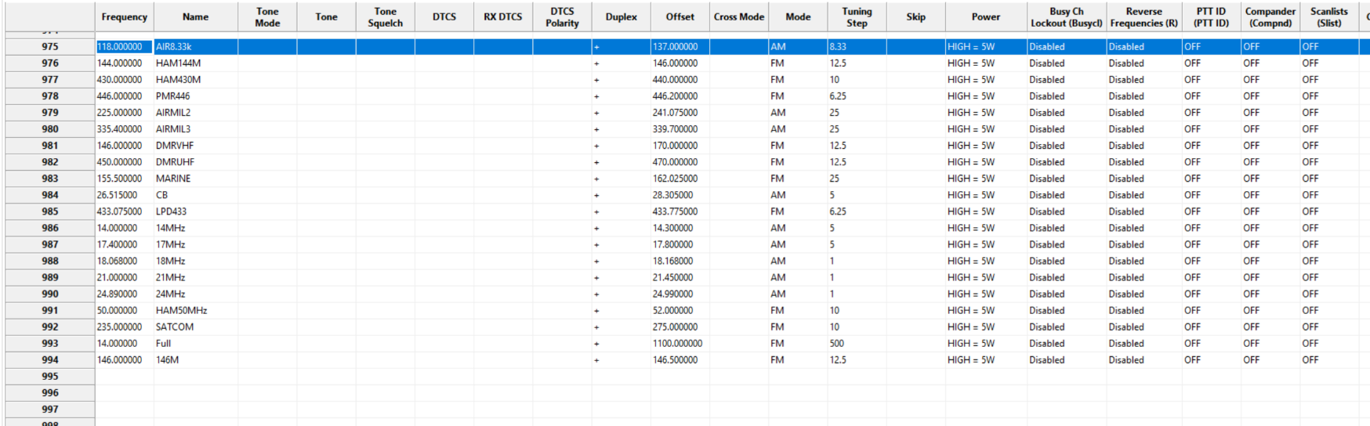
  - Modulation & Frequency Step.

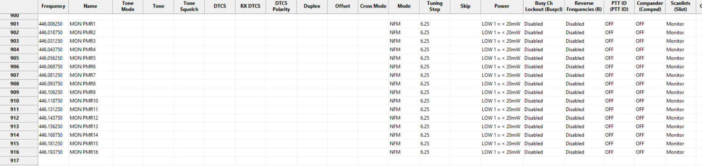
- Scanlist Monitor setting Select up to 20ch to Monitor scanlist anywhere in the channels.

